Warm-Up
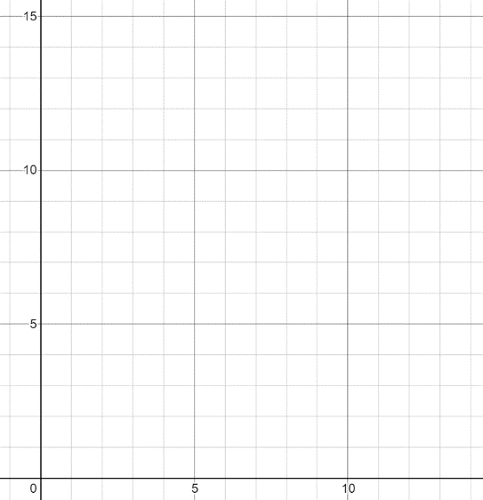
Your friend is being rude. You tell him to stop and he just gets worse. He starts harassing you saying “my phone is better than yours, my shoes are better than yours, my grades are better than yours . . . blah blah blah” He’s actually not that great of a friend. So, to get your point across that he needs to stop being rude you reacted by snatching his phone and drop kicking it as far as you can.

The path that his phone takes can be modeled by this equation $h\left(t\right)= -2t^{2}+10t$ where $t$ is time in minutes and $h(t)$ is the height of the phone in meters. Your kick is excellent and finally gets him to stop talking.
- Use your graphing calculator or Desmos to see what this function looks like. Sketch a picture of it here.

- What’s the highest his phone travels?

- How long was the phone in the air?

- What do you notice about this?

- What do you wonder or want to know more about?

Classwork: Key Elements & Graphing Standard Form
Name: ______________________________
Graphing Quadratics from Standard Form “${f(x)=Ax}^{2}+Bx+C$” … $[ x=\frac{-b}{2a} ]$
Key Elements: Axis of Symmetry, Vertex, Zeros, y-intercept, Min. or Max., Range, Key Points
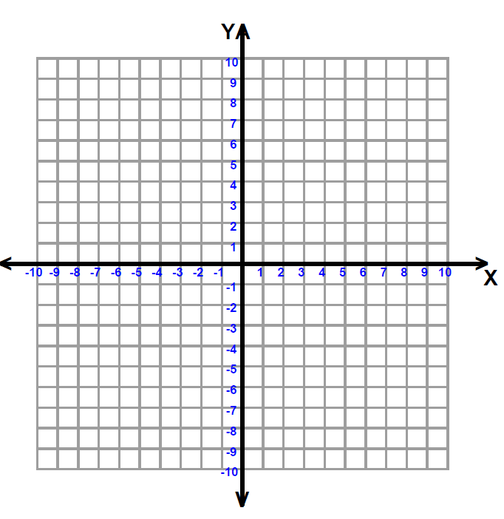
(solutions)
1. $f\left(x\right)=2x^{2}$

Vertex______ A.O.S. ______

Zero(s)________ y-int.______

Range_______ Min/Max? _____

A.O.S.
x
y
vertex

2. $f\left(x\right)=-x^{2}+9$

Vertex______ A.O.S. ______

Zero(s)________ y-int.______

Range_______ Min/Max? _____

A.O.S.
x
y
Vertex
3. $f\left(x\right)=-2x^{2}-8x$

Vertex______ A.O.S. ______

Zero(s)________ y-int.______

Range_______ Min/Max? _____

A.O.S.
x
y
Vertex

4. $f\left(x\right)=x^{2}-4x-5$

Vertex______ A.O.S. ______

Zero(s)________ y-int.______

Range_______ Min/Max? _____

A.O.S.
x
y
vertex

