Homework 5.1 - Trigonometry Day 1 Name: _____________________________________

Identify the three sides of each right triangle relative to the reference angle using the values given .

1. Reference angle Ө Reference angle α 2. Reference angle Ө Reference angle α
Hypotenuse = ______ Hypotenuse = ______ Hypotenuse=________ Hypotenuse=________
Opposite = ______ Opposite = ______ Opposite=__________ Opposite=_________
Adjacent = ______ Adjacent = ______ Adjacent=__________ Adjacent=_________
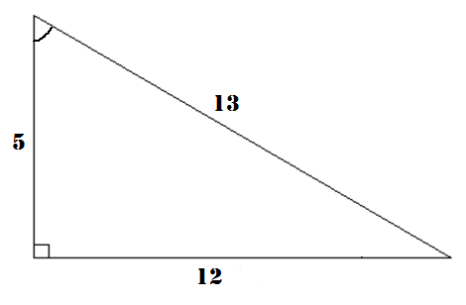
$$θ$$

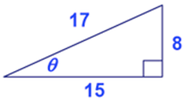

List all six ratios consisting of the Opposite, Adjacent and Hypotenuse using the reference angle given.
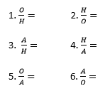
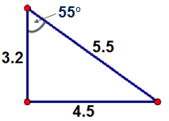
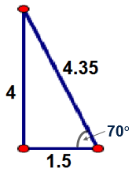
3. 1. $\frac{O}{H}=$ 2.$\frac{H}{O}=$ 4.
3.$\frac{A}{H}=$ 4.$\frac{H}{A}=$
5. $\frac{O}{A}=$ 6.$\frac{A}{O}=$

Homework 5.1 - Trigonometry Day 1 Name: _____________________________________

Identify the three sides of each right triangle relative to the reference angle using the values given .

1. Reference angle Ө Reference angle α 2. Reference angle Ө Reference angle α
Hypotenuse = ______ Hypotenuse = ______ Hypotenuse=________ Hypotenuse=________
Opposite = ______ Opposite = ______ Opposite=__________ Opposite=_________
Adjacent = ______ Adjacent = ______ Adjacent=__________ Adjacent=_________
$$θ$$

List all six ratios consisting of the Opposite, Adjacent and Hypotenuse using the reference angle given.
3. 1. $\frac{O}{H}=$ 2.$\frac{H}{O}=$ 4.
3.$\frac{A}{H}=$ 4.$\frac{H}{A}=$
5. $\frac{O}{A}=$ 6.$\frac{A}{O}=$

