Classwork: Similarity Challenge – Honors Name: ____________________________________

1. Triangle ABC is dilated to form triangle DEF. Point O is the center of the dilation. In this diagram $AD=0.5(OA)$
Which equation shows the relationship between the sizes of the two triangles?

- DE = 2AB

- EF = 2BC

- 2EF = 3BC

- 3AB = 2DF

2. This diagram shows streets on a map. 1st, 2nd, and 3rd streets are parallel.

What is the length of Main Street between 2nd Street and 3rd Street?

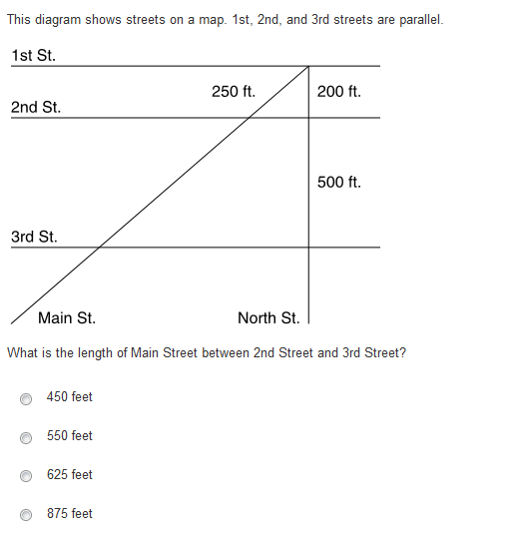
- 450 feet

- 550 feet

- 625 feet

- 875 feet

3. Larry is proving that the length of the segment joining the midpoints of two sides of a triangle is ½ the length of the third side.
He shows that 2WT = VT and 2TX = TU by applying the Segment Addition Postulate, substitution, and the definition of multiplication.
He then shows that ∠VTU ≅ ∠WTX because of the Reflexive Property.

Part A
Larry next states that ΔVTU ~ ΔWTX. What reason can he give for this statement?

Part B
Larry then concludes his proof. What is the reason for his last statement?

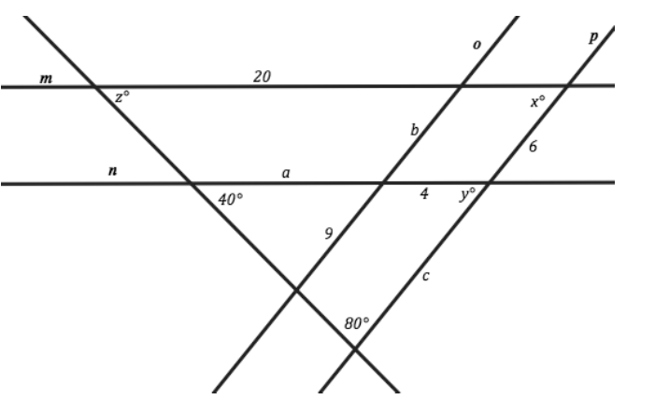
4. Line m ∥ n and o ∥ p, find the values of angles x, y and z. Also find the lengths of a, b and c.
Explain how you determined each answer.

5. A model train is made at a scale of 1 : 80. The real train’s measurements are shown below. Will the model fit
into packaging 18 cm long and 8 cm tall?

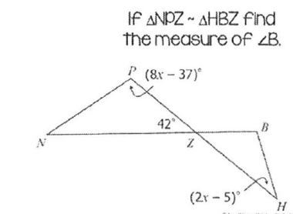
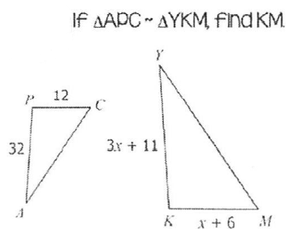
6. 7.

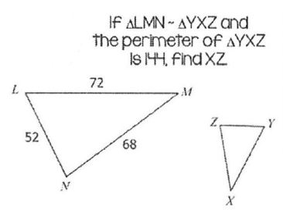
8.

