Review: Vertex & Factored form Name: ___________________________

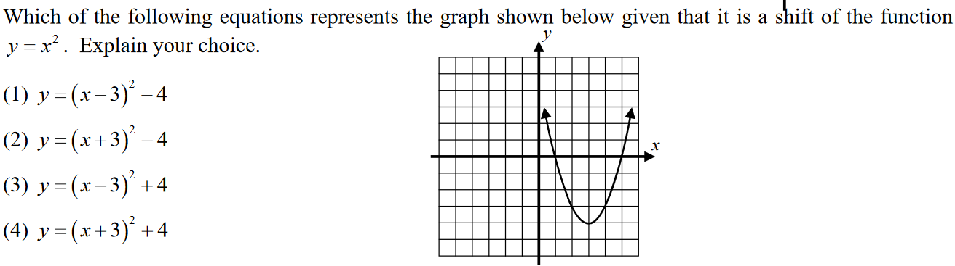
1.

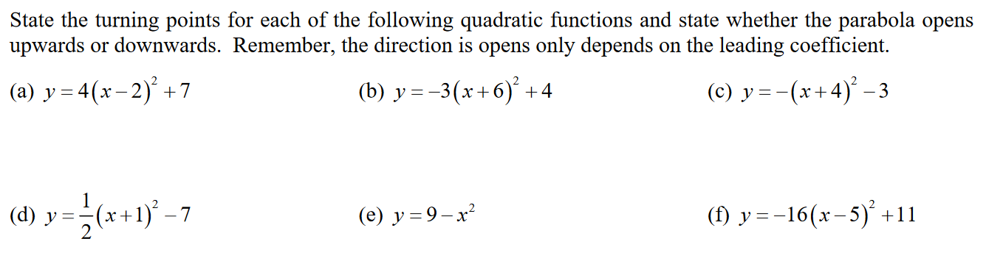
2.

3. Write a quadratic function in FACTORED FORM given the following
a. $Zeros are -2 and 5 opens up$
$f\left(x\right)=$__________________________________
b. $Zeros are 3 and 4 opens down$
$f\left(x\right)=$__________________________________
c. $Zeros are 0 and 2 opens up$
$f\left(x\right)=$__________________________________

4. Given: $f\left(x\right)=-2(x-3)(x+5)$

What is the A-value? _________ What does it tell you about the graph? _________________
Where are the zeros? ________________________ What is the A.O.S.? __________
Show how you would find the A.O.S. Algebraically using the zeros:

Where is the Vertex? ________ What is the y-intercept? $f\left(0\right)=$_____________
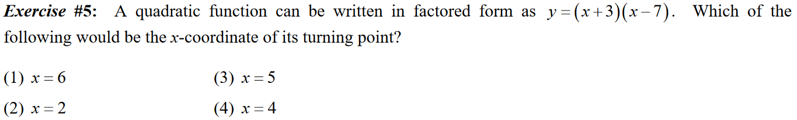

6. Given the following Quadratic function $f\left(x\right)= -\frac{1}{2}\left(x-4\right)\left(x+6\right)$ explain how you could find
the Zeros without using Desmos or a calculator:

7. Which Quadratic function has a zero at $x=4?$
a. $f\left(x\right)= -\left(x+1\right)\left(x+3\right)$ b. $f\left(x\right)= 3\left(x-4\right)\left(x+5\right)$ c. $f\left(x\right)= 4\left(x-2\right)\left(x+3\right)$

8. Which Quadratic function has an axis of symmetry $x=0$?
a. $f\left(x\right)= -\left(x+3\right)\left(x-3\right)$ b. $f\left(x\right)= 3\left(x-1\right)\left(x+4\right)$ c. $f\left(x\right)= \left(x+1\right)\left(x+2\right)$

9. Which Quadratic function equation gives the y- intercept?
a. $y=2{(x-3)}^{2}+4$ b. $y=2x^{2}-5x+1$

10. Which Quadratic function equation gives the vertex?
a. $y=-3{\left(x-2\right)}^{2}-5$ b. ${y=x}^{2}-2x-3$

11. Which Quadratic function equation gives information on whether the parabola opens up or
down?
a. $y=-\frac{1}{2}{(x-3)}^{2}+4$ b. $y=2x^{2}-5x+1$

12. Which of the following has a y-intercept equal to 3
a. ${y=x}^{2}+0x+3$ b. ${y=(x-0)}^{2}+3$
13. Write the equation of a Quadratic Function with a vertex at $(-3,5)$ and opens upward
_________________________________

