Guided Notes – Altitudes & Proof Name: ____________________________________

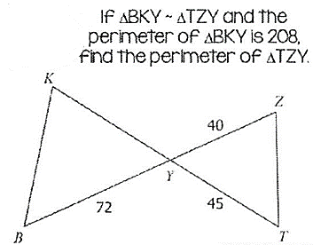
Warm Up

- Solve for $x=___________$

- If the perimeter of $∆BKY$ is 208, solve for $y=__________$

- Fins the Perimeter of $∆TZY= _____________$

Altitude: a line segment through a vertex and perpendicular to the opposite side.

Example 1:

Given: $∆TRY is isosceles$
$\overline{TX} is an altitude$

Prove: $\frac{YT}{TR}=\frac{YX}{XR}$

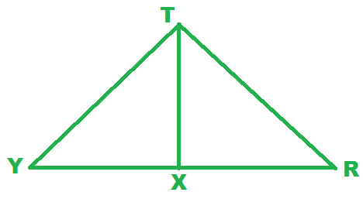

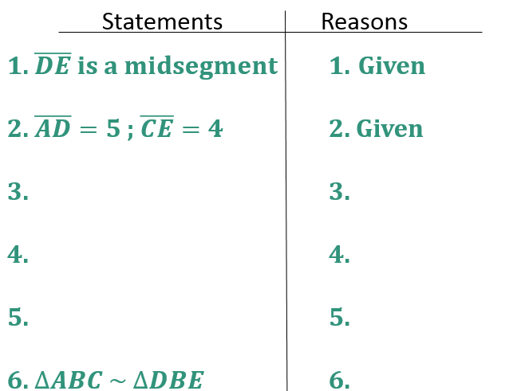
Example 2:

Given: $\overline{DE} is a midsegment$
$\overline{AD}=5$; $\overline{CE}=4$

Prove: $∆ABC \sim ∆DBE$
