Notes: MidSegment Theorem Name: __________________________

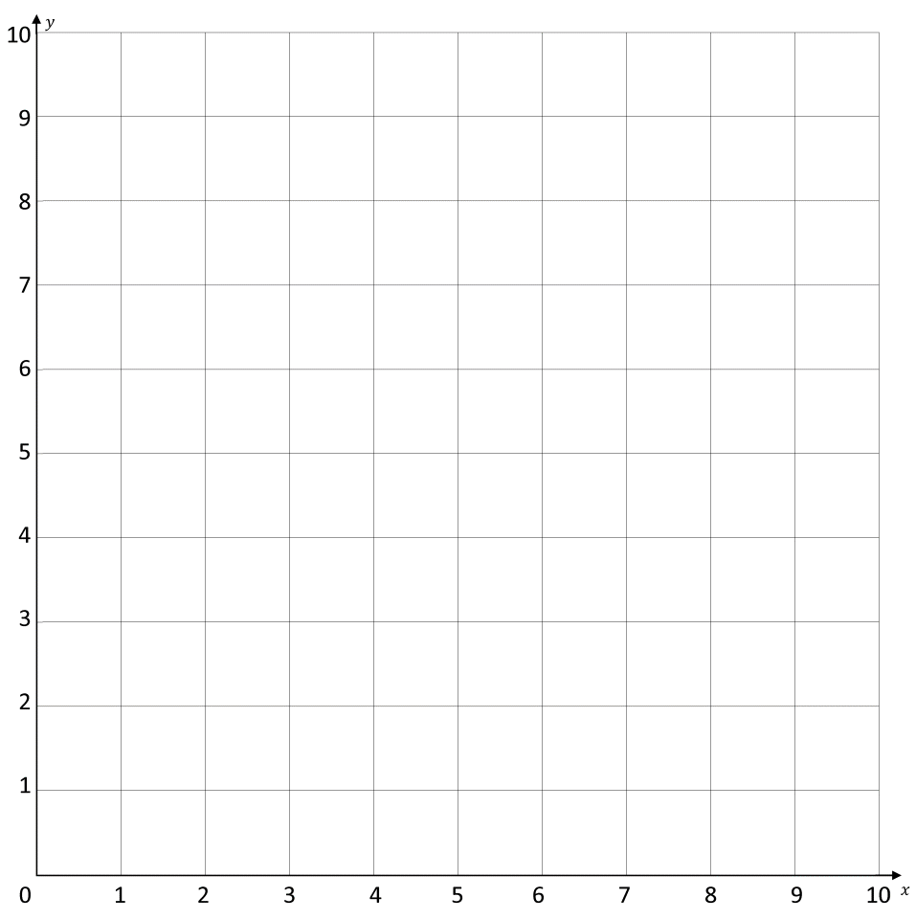
WARM UP
1. Plot $∆ABC$ where A(0, 0) B(0, 6) C(8, 0)

2. Find the midpoint of AC. Label it E.

3. Find the midpoint of AB. Label it F.

4. Draw a segment to connect point E and point F.

5. Find the length of EF ________________

6. Find the length of BC _______________

7. What do you notice about the 2 lengths?

8. Find the slope of EF __________

9. Find the slope of BC __________

10. What do you notice about the 2 slopes

11. Describe the transformation that happens from $∆ABC$ to $∆AEF$.

_______________________ Theorem

A _______________________________ connecting two sides of a triangle is parallel to the third side and is half as long.
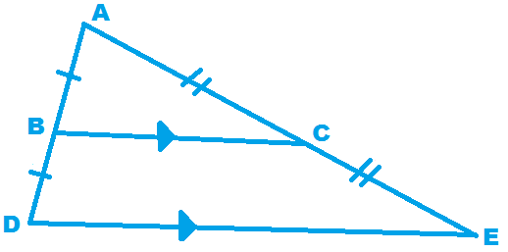
If B is the midpoint of $\overline{AD}$ and C is the midpoint of $\overline{AE},$

Then $\overline{BC}∥\overline{DE}$ and $BC=\frac{1}{2}DE$

Example 1: Solve for $x=____________$ Example 2: Use the diagram of $∆ABC$ where D, E, and F are
the midpoints of the sides.
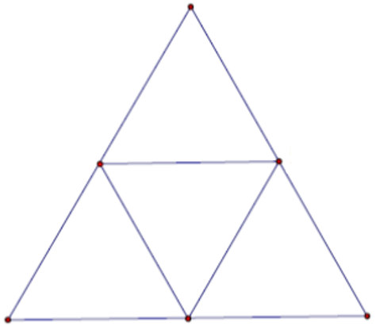
- $\overline{DE}∥___________$

- $\overline{AB}∥ ___________$

- If $AB=14,$ then $EF= _________$

- If $AE=8,$ then $DF= _________$

- If $DE=6,$ then $BC= _________$

Understanding Check:
What are the three key properties or characteristics of a midsegment?

1.

2.

3.

