Homework 4.6 – Similarity Shortcuts Day 2 Name: ___________________________________

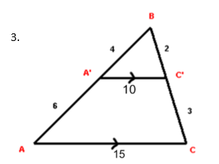
Determine if the triangles are similar. Show all your work to support the postulate or theorem you choose. Write a similarity statement if they are similar or “Not Similar” if they’re not.
B
A
A’
C
C’
6
3
2
4
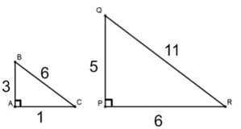
1. 2.

3. Show your work. 4. Write the similarity proof.
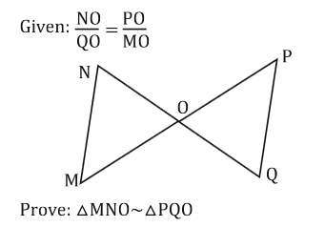
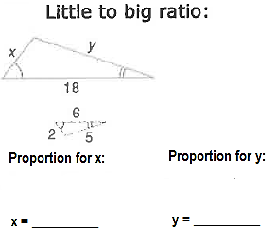

Statement | Reason
1. | 1.
2. | 2.
3. | 3.

5. Prove: $∆ABE \sim ∆CBD$ 6. Are the triangles similar? If not, write “not similar”.

1. $\overline{AE}∥\overline{CD}$

2.

3.

4.
Statements
Reasons
1. Given

2.

3.

4.

